- A person has a problem of continuous bleeding in a simple injury. For solving this problem he went to a hospital to test blood. The report of the test is given in the following table.
Blood cell | Number in per mm³ of blood
RBC | 38,45,000
WBC | 9,500
Platelets | 90,000

i) Which blood cell is in normal count in his blood?
ii) Which disease may he suffering from?
iii) Does he have any other health problem according to the report? Write.
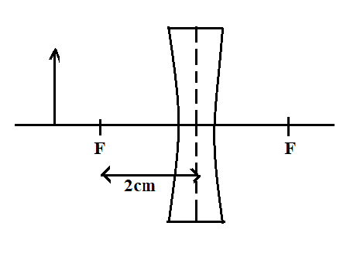
- Complete the given ray diagram. Which type of lens is used in diagram? Calculate the power of lens. Write two nature of image formed. Also give an application of it.

- How does heat affect the rate of chemical reaction?
When a burning ribbon of a metal was taken in a jar containing gas, it formed white and black powder. The white powder can be used as medicine to cure hyperacidity.
i) What happens when the white powder is dissolved in water? Write balanced chemical equation.
ii) How does the solution help to reduce the hyperacidity of stomach?
- Draw a well labeled diagram of the laboratory preparation of ammonia gas with its principle reaction and a test to verify it.

THE END

Siddhi Vinayak Secondary School
Butwal-15, Mainapur, Rupandehi
Second Terminal Examination- 2083
Class: 10 F.M=75 Time: 3hrs Subject-Science P.M=30

Students are required to answer in their own words as far as practicable. Credit shall be given to clarity and originality, not rote knowledge.
Attempt all the questions:
Group 'A'
- Multiple choice questions: [10×1=10]
- What are the main features of organisms under kingdom plantae?
i) Eukaryotic cell, cell with cell wall, heterotrophs
ii) Eukaryotic cell, cell without cell wall, heterotrophs
iii) Eukaryotic cell, cell with cell wall, autotrophs
iv) Eukaryotic cell, cell with cell wall, saprotrophs
- Why cycas is kept in gymnosperm?
i) Bears flowers, produces seed
ii) Bear flowers, leaves are needle like
iii) Bears cones instead of flowers, seeds are naked without fruit.
iv) Bears cones instead of flowers, seeds are enclosed in fruit.
- Which of the following is the genotypic ratio for monohybrid cross?
i) 1:2 ii) 3:1
iii) 1:2:1 iv) 9:2:3:1
- What is the term for characteristics that is passed down from generation to generation called?
i) Dominant character ii) Recessive character
iii) Hereditary character iv) Imported character
- Which part of the blood helps in transportation of oxygen in our blood?
i) RBC ii) WBC
iii) Platelets iv) Plasma
- Nowadays, sometimes there is low rainfall and sometimes heavy rainfall, which has affected the agricultural production. What may be the reason for this?
i) Volcanic eruption ii) Climate change
iii) Change in atmospheric pressure iv) Decline of rare wildlife

- If the gravitational force between two objects on earth is 60 N, What is the gravitational force between those two objects on the moon?
i) 10 N ii) 6 N
iii) 9.8 N iv) 60 N
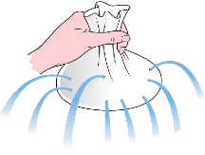
- Which law can be demonstrated by the diagram shown alongside?
i) Archimedes principle ii) Law of floatation
iii) Pascal’s law iv) Boyle’s law
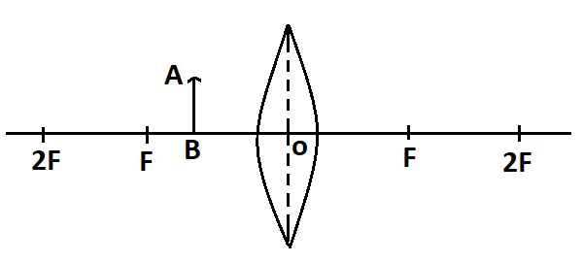
- Identify the characteristics of the image of the object AB kept in front of the lens as shown in the figure.
i) Virtual, erect and magnified
ii) Real, inverted and diminished
iii) Real, erect and magnified
iv) Virtual, inverted and diminished
- The term big bang refers to…………
i) a supernova explosion iii) a TV show
ii) the origin of our universe iv) fate of our universe

Group B
- Write very short answer to the following questions. [9 × 1 = 9]
- State Archimedes principle.
- Mention the forces acting on a floating object and their direction.
- The specific heat capacity of mercury is 138 J/kg⁰C. What does it mean?
- Define anomalous expansion of water.
- Which gas is collected by downward displacement of air? Why?
- Write the cause of refraction of light.
- State Big bang theory.
- Define baseband transmission.
- Write down the function of tube feet found in star fish.
Group 'C'
Write short answer to the questions: [14×2=28]
- Shark and whale both live in water. Based on their features, which is more developed animal? Explain with reasons.
- Write down any two differences between drone and worker bee.
- Why Mendel did selected pea plants for his experiment?
- Which blood vessels have valve and why?
- Write down the main reasons for extinction of animals.
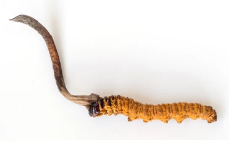
- Identify and name the given diagram and write its one use.

- Under what conditions is an object said to be in freefall? Write down the conclusion of feather and coin experiment.
- If the mass of the moon is 7.342 × 10²² kg and its radius is 1737 km, calculate its acceleration due to gravity. Where G = 6.67 × 10⁻¹¹ Nm²/kg².
- Why the tap of the ground floor fills an equal sized bucket more quickly than that in the top floor?
- Mention the relation between density of liquid and its upthrust. It is easier to swim in sea water than in river?
- Define Bit and Byte that are used in computer memory.
- Write down any two differences between open universe and closed universe.
- Why we use water in hot water bag? Explain.
- Write down the balanced chemical reaction between Aluminium metal and dilute hydrochloric acid. Mention the type of reaction with reason.
Group 'D'
Write long answers to the questions: [7×4=28]
- Rounded seeded pea plant and wrinkled seeded pea plant are cross pollinated first and then the offspring obtained were self-pollinated again. The result of second filial generation is shown in the table below. Now answer the following questions:
 | R | r
R | RR | Rr
r | Rr | rr
i) What is the ratio of plants showing dominant and recessive characters?
ii) Write the genotypic and phenotypic ratio of this generation.
iii) Among them, which plant is purely round-seeded? Why?

- What is DNA testing? Mention any four purpose of using it.
- Write any two differences between artery and vein. How does blood flow from right ventricle to left auricle? Explain.

